Agricultural AI for Smart Farming
A Mini Project Report Submitted in partial fulfillment of the requirements for the award of the degree of

BACHELOR OF TECHNOLOGY
In

DEPARTMENT OF COMPUTER SCIENCE AND ENGINEERING
Or

DEPARTMENT OF COMPUTER SCIENCE AND INFORMATION TECHNOLOGY
Or

DEPARTMENT OF ARTIFICIAL INTELLIGENCE AND DATA SCIENCE
By
Rithvik-2420090037
P.Akshaya-2420030628
B.Niharika-2420030601
Surya-2420090001
Under the Esteemed Guidance of
K.Swanthana





K L (Deemed to be) University

DEPARTMENT OF COMPUTER SCIENCE AND ENGINEERING
Or

DEPARTMENT OF COMPUTER SCIENCE AND INFORMATION TECHNOLOGY
Or

DEPARTMENT OF ARTIFICIAL INTELLIGENCE AND DATA SCIENCE

DECLARATION

The mini-project report entitled “Agricultural AI for Smart Farming” is a record of bona fide work carried out by [Rithvik-2420090037,P.Akshaya-2420030628,B.Niharika-2420030601,Surya-2420090001] in partial fulfillment of the requirements for the award of the B.Tech degree at K L (Deemed to be) University. The work presented in this report is original to the best of our knowledge, and all datasets, tools, code, and external sources used have been appropriately acknowledged.
Rithvik-2420090037
P.Akshaya-2420030628
B.Niharika-2420030601
Surya-2420090001

K L (Deemed to be) University

DEPARTMENT OF COMPUTER SCIENCE AND ENGINEERING

Or

DEPARTMENT OF COMPUTER SCIENCE AND INFORMATION TECHNOLOGY
Or

DEPARTMENT OF ARTIFICIAL INTELLIGENCE AND DATA SCIENCE

CERTIFICATE

This is to certify that the mini-project report entitled “Agricultural AI for Smart Farming” is a bona fide work carried out by [Rithvik-2420090037,P.Akshaya-2420030628,B.Niharika-2420030601,Surya-2420090001] under the supervision of [K.Swanthana] during the academic year [20 –20 ], in partial fulfillment of the requirements for the award of the Bachelor of Technology degree at K L (Deemed to be) University.

Signature of the Project Supervisor

Signature of the HOD Signature of the External Examiner

ACKNOWLEDGEMENT
The success in this project would not have been possible but for the timely help and guidance rendered by many people. Our wish to express my sincere thanks to all those who has assisted us in one way or the other for the completion of my project.

Our greatest appreciation to my guide, K.Swanthana, Department of Computer Science which cannot be expressed in words for his/her tremendous support, encouragement and guidance for this project.

We express our gratitude to Dr. P.Venkateshwar Sir (CSE)/Dr. Kaja Shareef Sir (CSIT)/Dr.Sreenath, Head of the Department for Computer Science Engineering/ Department for Computer Science and Information Technology/ Department Of Artificial Intelligence And Data Science for providing us with adequate facilities, ways and means by which we are able to complete this project-based Lab.

We thank all the members of teaching and non-teaching staff members, and also who have assisted me directly or indirectly for successful completion of this project. Finally, I sincerely thank my parents, friends and classmates for their kind help and cooperation during my work.

Rithvik-2420090037

P.Akshaya-2420030628

B.Niharika-2420030601

Surya-2420090001

TABLE OF CONTENTS

S.No. | Contents | Page no.
1. | Abstract | 7
2. | Introduction | 8
3. | Literature survey | 9-12
4. | Problem Statement and Objectives | 12-13
5. | Hardware and Software requirements | 14
6. | Implementation | 15-25
7. | Results & Discussion | 26-32
8. | Conclusion & Future Scope | 33
9. | References | 34

ABSTRACT

Agriculture faces challenges such as crop diseases, inefficient resource utilization, changing weather conditions, and uncertain crop yields. This project, Agriculture for AI and Sustainability, presents AgriBuddy AI, an AI-powered smart agriculture system designed to support data-driven farming decisions. The application domain is smart and sustainable agriculture, focusing on agricultural prediction and decision support. The system uses agricultural datasets relevant to its implemented prediction tasks. The dataset names, sources, and sizes should be specified according to the actual datasets used in the project.
Data preprocessing involves handling missing values, selecting relevant features, encoding categorical variables, and scaling numerical features where required by the selected algorithms. Random Forest, XGBoost, Support Vector Machine (SVM), LightGBM, and Decision Tree are implemented for agricultural prediction tasks. In addition, a weighted-average fusion model combines Random Forest and XGBoost predictions. Text representation techniques such as TF-IDF or embeddings are applicable only if a text analytics component is implemented; they should not be reported otherwise. Classification models can be evaluated using accuracy, precision, recall, and F1-score, while regression models can be evaluated using MAE, RMSE, and R². The actual evaluation results must be inserted from the experiments conducted. The system follows a Service-Oriented Architecture (SOA), separating functionalities into independent services. Its practical significance lies in supporting informed farming decisions, improving resource management, and encouraging sustainable agricultural practices.

Team Members and Responsibilities:

1.Rithvik-2420090037:Backend Developer
2.Surya-2420090001: Frontend and Testing Developer
3.P.Akshaya: Machine Learning Model Developer
4.B.Niharika-2420030601: Dataset and Data Preprocessing Developer

INTRODUCTION

Agriculture is an essential sector that supports food production, economic development, and environmental sustainability. Farmers face several challenges, including crop diseases, unpredictable weather conditions, inefficient irrigation, and uncertainty in crop yield. Artificial Intelligence (AI) and Machine Learning (ML) can help address these challenges by analyzing agricultural data and identifying useful patterns to support informed farming decisions. Manual analysis of large amounts of agricultural information is time-consuming and may make it difficult to identify relationships between environmental conditions and crop performance.
The proposed project, Agriculture for AI and Sustainability, introduces AgriBuddy AI, an AI-powered smart agriculture system designed to assist farmers, agricultural students, and other users interested in farming decisions. The system analyzes agricultural and environmental input data to generate predictions for relevant farming tasks. Depending on the implemented service, inputs may include soil properties, temperature, humidity, rainfall, and crop-related information, while outputs may include crop recommendations, disease predictions, irrigation requirements, and yield forecasts.
The proposed pipeline consists of data collection, preprocessing, feature selection where required, model training, prediction, and performance evaluation. The implemented algorithms include Random Forest, XGBoost, Support Vector Machine (SVM), LightGBM, and Decision Tree. A weighted-average fusion model combining Random Forest and XGBoost is also implemented. The system follows a Service-Oriented Architecture (SOA), with independent services communicating through APIs. A user interface enables users to enter relevant information and view prediction results.
The remaining chapters describe the literature review, system methodology, implementation, experimental evaluation, results, and conclusion with future enhancements.

LITERATURE SURVEY

1. Mahale et al. (2024) — Crop Recommendation and Weather Forecasting
Mahale et al. developed a crop recommendation system for Maharashtra using historical weather data from 2001–2022.
The dataset was obtained from the India Meteorological Department and included weather parameters such as rainfall and temperature.
Expectation-Maximization was used to handle missing data, while Random Forest achieved 92% accuracy for crop recommendation.
An LSTM model forecast weather conditions three months ahead to support crop selection and crop-calendar planning.
However, the study focuses on Maharashtra, so its results may not generalize directly to other agricultural regions .

2. Yenkikar et al. (2025) — Explainable AI for Crop Yield Prediction
Yenkikar et al. proposed a hybrid machine learning model to improve crop-yield prediction and make its decisions more interpretable.
The study used agricultural production records from India, including crop, season, area, production, and yield information.
The model combined LSTM, Random Forest, and XGBoost, with SHAP, LIME, and other explainability methods.
The paper reported \(R^2=0.9827\) for crop-yield prediction and \(R^2=0.9721\) for rice-yield prediction.
Its limitations include regional data coverage, changing environmental conditions, and the need for further real-world validation .

3. Shawon et al. (2025) — Systematic Review of Crop-Yield Prediction
Shawon et al. reviewed research on machine learning methods for crop-yield prediction published between 2017 and 2024.
The authors screened research from eight electronic sources and selected 97 papers for detailed analysis.
The review identified Linear Regression, Random Forest, and Gradient Boosting as commonly used methods, alongside CNN and LSTM models.
It highlighted the importance of factors such as temperature, soil type, and vegetation in yield prediction.
As a review study, it synthesizes previous research rather than validating one new prediction model, and reported performance varies across datasets .

4. Jabed and Murad (2024) — Review of Machine Learning and Deep Learning for Crop Yield
Jabed and Murad reviewed machine learning and deep learning approaches used to predict crop yields and support sustainable agriculture.
The paper discusses how predictive models can help farmers and agricultural planners respond to environmental and production challenges.
It compares traditional machine learning approaches with deep learning techniques used for agricultural prediction.
The review emphasizes the importance of choosing suitable data features and models for reliable yield estimation.
A limitation of a review-based study is that it does not, by itself, demonstrate the performance of a single integrated farming application .

5. Kulkarni et al. (2025) — AI and Machine Learning for Precision Agriculture
Kulkarni et al. proposed an AI-based precision-agriculture framework combining sensor-related data and machine learning with image-based disease detection.
The study used 54,303 PlantVillage leaf images to train a CNN for plant-disease classification and also explored soil-moisture and plant-stress prediction.
The authors reported 90.45% validation accuracy for disease classification and 95% accuracy for the plant-stress classifier.
The framework illustrates how several AI methods can support crop monitoring and resource management.
However, the use of different datasets and prediction tasks means that the results do not establish the performance of one unified model across all agricultural functions [5].

6. Umamaheswari and Kavitha (2026) — Machine Learning Techniques for Smart Agriculture
Umamaheswari and Kavitha reviewed 30 research articles on smart agriculture published within their selected 2023–2026 research period.
The review covered crop recommendation, disease detection, weather forecasting, and IoT-supported precision farming.
It compared traditional machine learning, ensemble methods, and deep learning models such as Random Forest, SVM, Decision Trees, CNN, and LSTM.
The authors identified benefits in predictive farming while highlighting barriers such as implementation cost, limited technical skills, connectivity, and scalability.
As the study is a review rather than a new end-to-end implementation, it leaves room for practical systems integrating several agricultural services .

Comparison of Existing Approaches
Approach | Main strength | Limitation addressed by AgriBuddy AI
Crop recommendation with RF and LSTM | Recommends crops using weather forecasts | AgriBuddy also includes disease, irrigation, and yield modules
Hybrid yield prediction | Combines ML models and explainability | AgriBuddy compares multiple models and provides several agricultural services
Yield-prediction reviews | Summarize algorithms and influencing factors | AgriBuddy implements models rather than only reviewing them
Precision agriculture framework | Combines sensor-related data and image-based diagnosis | AgriBuddy brings multiple functions together through API-based services
Smart-agriculture review | Identifies methods and deployment challenges | AgriBuddy demonstrates a full-stack application with separate backend endpoints

Research Gap
Existing studies show that machine learning can improve crop recommendation, plant-disease detection, irrigation planning, and yield prediction. However, many studies concentrate on a specific agricultural task or evaluate different tasks independently. AgriBuddy AI addresses this project-level gap by integrating crop recommendation, plant-disease detection, irrigation prediction, yield forecasting, fertilizer recommendations, and a multilingual agricultural assistant into one web application. Its API-based modular design supports independent agricultural services, while multiple machine learning algorithms can be evaluated for relevant tasks. The current prototype uses simulated sensor telemetry; physical IoT hardware integration and further real-world field validation remain future work.
1. Y. Mahale, N. Khan, K. Kulkarni, S. A. Wagle, P. Pareek, K. Kotecha, T. Choudhury, and A. Sharma, “Crop recommendation and forecasting system for Maharashtra using machine learning with LSTM: a novel expectation-maximization technique,” Discover Sustainability, vol. 5, article 134, 2024. https://doi.org/10.1007/s43621-024-00292-5
2. A. Yenkikar, V. P. Mishra, M. Bali, and T. Ara, “An explainable AI-based hybrid machine learning model for interpretability and enhanced crop yield prediction,” MethodsX, vol. 15, article 103442, 2025. https://doi.org/10.1016/j.mex.2025.103442
3. S. M. Shawon, F. B. Ema, A. K. Mahi, F. L. Niha, and H. T. Zubair, “Crop yield prediction using machine learning: An extensive and systematic literature review,” Smart Agricultural Technology, article 100718, 2025. https://doi.org/10.1016/j.atech.2024.100718
4. M. A. Jabed and M. A. A. Murad, “Crop yield prediction in agriculture: A comprehensive review of machine learning and deep learning approaches, with insights for future research and sustainability,” Heliyon, vol. 10, no. 24, e40836, 2024. https://doi.org/10.1016/j.heliyon.2024.e40836
5. S. D. Kulkarni, P. S. Tomar, A. Chakravarty, C. K., K. Hema, S. Bhaumik, and M. D. B., “Artificial Intelligence and Machine Learning Applications in Precision Agriculture: Enhancing Crop Yield Prediction, Disease Detection, and Resource Optimization,” International Journal of Applied Mathematics, vol. 38, no. 11s, 2025. https://doi.org/10.12732/ijam.v38i11s.1300
6. M. Umamaheswari and K. D. Kavitha, “Machine learning classification techniques for smart agriculture: a review of disease detection and crop recommendation,” Frontiers in Artificial Intelligence, vol. 9, article 1878006, 2026. https://doi.org/10.3389/frai.2026.1878006

PROBLEM STATEMENT AND OBJECTIVES

Problem Statement:
To develop an AI-powered smart agriculture system that uses machine learning to provide crop recommendations, detect plant diseases, estimate irrigation requirements, and predict crop yield to support better farming decisions.
Problem Description:
Farmers often face challenges in selecting suitable crops, identifying plant diseases, managing irrigation, and estimating crop yield. Traditional methods may require considerable time and expert assistance. AgriBuddy AI aims to provide these services through a single web application using machine learning models and independent API-based modules. The system also provides fertilizer recommendations and multilingual agricultural assistance.

Objectives:
Develop a system using suitable agricultural datasets for crop recommendation, disease detection, irrigation prediction, and yield forecasting.
Preprocess agricultural data and plant images according to the requirements of each machine learning task.
Train and compare suitable algorithms, including Random Forest, XGBoost, LightGBM, Decision Tree, and SVM, for the relevant tasks.
Evaluate model performance using appropriate metrics such as accuracy, precision, recall, F1-score, MAE, RMSE, and R².
Integrate agricultural prediction functions through independent API-based services within the AgriBuddy AI application.
Implement fertilizer recommendations, weather-based advisories, and a multilingual agricultural assistant.
Test the application's API endpoints, frontend integration, and core functionalities.
Document model limitations, data quality issues, and future improvements, including real-world validation and physical IoT sensor integration.

HARDWARE AND SOFTWARE REQUIREMENTS

Hardware Requirements
- A computer or laptop with a modern multi-core processor.
- Minimum 8 GB RAM; 16 GB RAM is recommended for smoother execution.
- Internet connection for downloading datasets, installing packages, and accessing weather information.
- Sufficient disk space to store agricultural datasets, plant images, source code, and trained machine learning models.
- GPU is optional for the implemented classical machine learning algorithms.
Software Requirements
- Operating System: Windows 10/11 or Linux.
- Frontend: React 18, TypeScript, Vite, and Tailwind CSS.
- Backend: Python 3.x with FastAPI and Uvicorn.
- Database: PostgreSQL 15 or later.
- Machine Learning: scikit-learn, XGBoost, LightGBM, pandas, and NumPy.
- Data Visualization: Matplotlib and Seaborn, if required for result analysis.
- Plant Disease Detection: Image-processing and machine learning libraries required by the implemented model.
- Dataset Sources: Agricultural crop and yield datasets and plant-leaf image datasets from sources such as Hugging Face. Dataset licences and sources should be documented.
- Development Tools: Visual Studio Code, Git, and a web browser.
- Testing Tools: Python testing libraries such as pytest and a browser-based frontend testing environment.
- Optional Integrations: Weather APIs, Google Gemini API, and physical IoT sensors, subject to configuration and availability.

IMPLEMENTATION

- Data and task: AgriBuddy AI performs multiple agricultural machine learning tasks, including crop recommendation, plant disease detection, irrigation prediction, and crop yield forecasting. Crop recommendation uses soil nutrient information and other agricultural features to recommend a suitable crop. Plant disease detection classifies leaf images into disease categories, while irrigation and yield modules estimate water requirements and crop production.
Target labels: AgriBuddy AI consists of four major agricultural prediction tasks: crop recommendation, plant disease detection, irrigation prediction, and crop yield forecasting.
A. Crop Recommendation:The objective is to recommend a suitable crop based on agricultural inputs such as soil nitrogen (N), phosphorus (P), potassium (K), and other available features. The target label is the crop name. This is a multiclass classification problem because the model selects one crop from multiple possible classes. The QA report records 2,200 records and 22 crop classes.
B. Plant Disease Detection:The objective is to identify plant diseases from uploaded leaf images. The target label is the corresponding disease category. This is a multiclass image-classification problem, and the QA report records 32 pathology classes. The system also provides confidence information and disease-management recommendations.
C. Irrigation Prediction:The objective is to estimate the water requirement of crops based on agricultural and environmental inputs. The numerical target is the estimated irrigation requirement, measured in millimetres or litres per acre. Regression models estimate water requirements, while classification can be used to identify irrigation urgency.
D. Crop Yield Forecasting:The objective is to estimate expected crop production using relevant agricultural information.The target is the predicted crop yield, expressed in quintals per acre. Regression models are used to estimate yield, and the application uses the prediction to calculate projected gross farm revenue.

Dataset source: AgriBuddy AI uses agricultural data and plant-leaf image datasets for training and evaluation. The QA report identifies the following Hugging Face dataset repositories as image-data resources
Dataset size and split: The available QA report documents the following information

Task | Dataset information available
Crop recommendation | 2,200 records and 22 classes
Plant disease detection | 32 pathology classes; total image count not specified
Irrigation prediction | Dataset record count not specified
Crop yield forecasting | Dataset record count not specified

Licence and usage conditions: Each dataset must be checked at its original source before it is used or redistributed. Record the dataset name, creator, source URL, licence, date accessed, and any attribution or redistribution requirements. Do not assume that all Hugging Face datasets have the same licence. If a dataset has no clearly specified licence, seek permission or choose a dataset with suitable usage terms.
Training, validation and test split
The QA report does not specify the exact train/validation/test split used to obtain the reported model results. These values must be checked in the training scripts.
For a new or reproducible experiment, a possible split is:
.Training set: 70% of the records.
.Validation set: 15% of the records.
.Test set: 15% of the records.
This is a proposed split, not a verified description of the existing models. For classification, use stratified splitting where appropriate to preserve class proportions. For plant images, avoid placing near-duplicate images of the same source leaf in different sets. For time-dependent agricultural forecasting, use a chronological split when appropriate so that future records do not leak into training.

Data Preprocessing and Feature Preparation
Data preprocessing prepares raw agricultural data for machine learning. The steps depend on whether the input consists of structured numerical data or leaf images.
A. Missing-value handling
Check numerical and categorical features for missing values. Remove records only when justified, or impute missing values using an appropriate method. For numerical variables, mean or median imputation may be considered; categorical features may require a separate missing category or a suitable imputation strategy. Fit imputation values using the training set only.
B. Duplicate removal
Check for exact duplicate records and remove inappropriate duplicates before splitting the dataset. For image datasets, check for duplicate or near-duplicate images to reduce the risk of data leakage. Preserve valid repeated measurements when they represent genuinely different observations.
C. Feature selection and encoding
Select relevant features for each task. Crop recommendation may use soil nutrient values and other available agricultural variables. Irrigation prediction uses relevant environmental and water-requirement variables, while yield prediction uses the available production-related features. Encode categorical variables appropriately if the chosen model requires numerical inputs.
D. Numerical feature scaling
Scaling transforms numerical features to a comparable range. It is particularly important for SVM because the model can be sensitive to feature magnitudes. Tree-based algorithms such as Random Forest, Decision Tree, XGBoost, and LightGBM generally do not require the same feature scaling.
A scaler, if used, must be fitted on the training data and then applied unchanged to validation and test data.
E. Leaf-image preprocessing
The disease-detection workflow checks whether uploaded images contain valid plant content and whether the images are excessively blurry. The QA report documents non-plant image rejection using a vegetation-ratio filter and blurry-image handling using a Laplacian edge-variance filter. These checks help prevent unsuitable images from being processed as valid leaf samples.
The exact image resizing, normalization, augmentation, and model-specific transformation steps must be documented from the image-training pipeline.

2.NLP preprocessing and features: The primary AgriBuddy AI prediction tasks use structured agricultural data and plant images. Therefore, standard text-processing techniques such as TF-IDF are not required for crop recommendation, irrigation regression, yield regression, or leaf-image classification.
However, the agricultural assistant accepts text queries from users. If the assistant's queries are classified into categories such as crop recommendation, disease assistance, irrigation, or fertilizer advice, the following NLP workflow could be implemented.
A. Missing or empty text
Check whether a user query is empty or missing. Empty inputs should be rejected or handled with a request for clarification.
B. Duplicate text
Identify duplicate records in a labelled text dataset before training. Repeated examples should be reviewed because they may cause an overly optimistic evaluation if similar text appears in both training and test sets.
C. Lowercasing
Convert text to lowercase when case does not affect the meaning of the task. This can help treat words such as “Crop” and “crop” consistently. For multilingual text, preserve scripts and characters correctly.
D. Tokenization
Split text into words or tokens. Tokenization should preserve useful agricultural terms, crop names, abbreviations, and relevant numerical values.
E. Stop-word handling
Stop words are common words that may contribute little to a particular classification task. Remove them only when experiments show that doing so is useful. Words that express negation, such as “not,” must not be removed blindly because they can change the meaning of a farmer's query.
F. Stemming and lemmatization
Stemming reduces words to approximate roots, while lemmatization converts words to their base forms. These techniques may help with English text classification, but their suitability depends on the language and task. Telugu and Hindi text require language-appropriate processing; English stemming rules should not be applied to them indiscriminately.
G. Text feature extraction
Possible feature-extraction methods include:
Bag of Words (BoW): Represents text using word counts.
TF-IDF: Gives higher importance to words that are informative within a dataset.
Text embeddings: Represent text as numerical vectors that can capture semantic similarity.
For a small labelled farmer-query classification dataset, TF-IDF with a suitable classifier is a reasonable baseline. For multilingual semantic classification, suitable multilingual embeddings may be explored.

Login page:

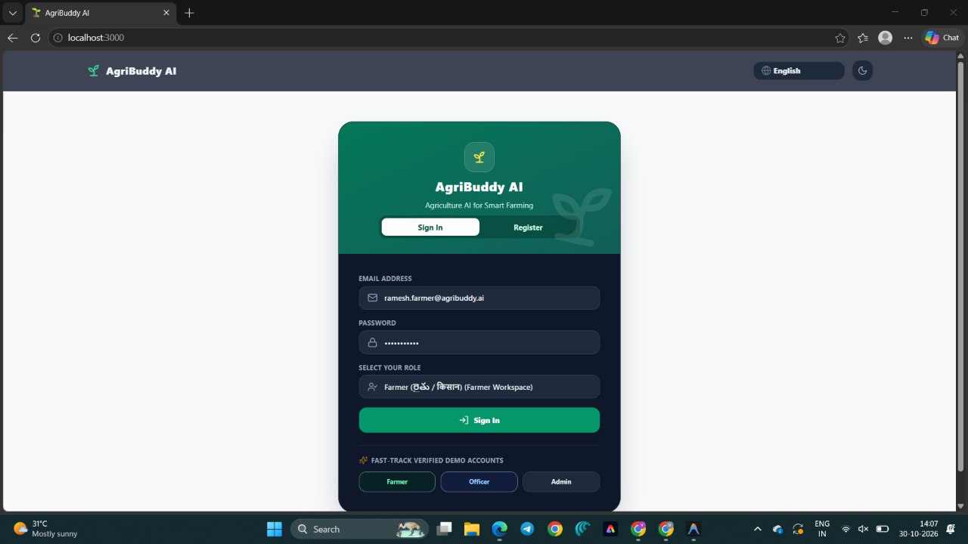

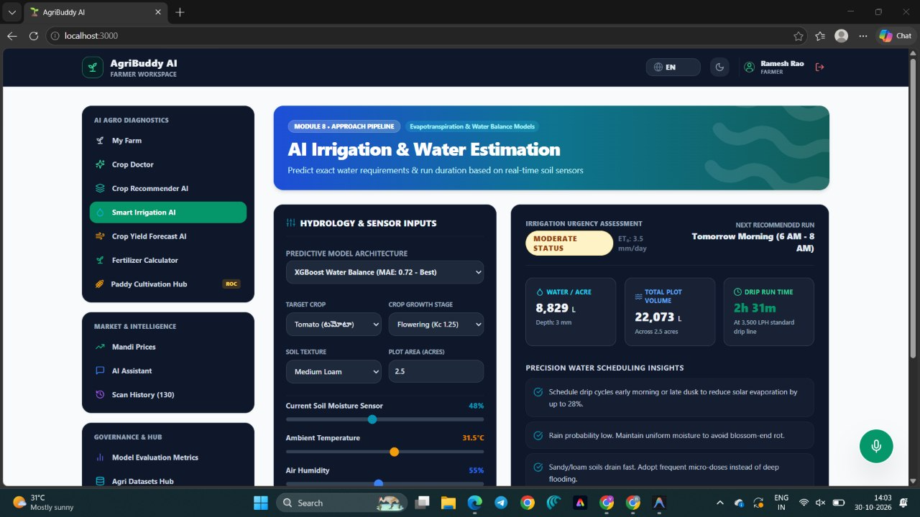

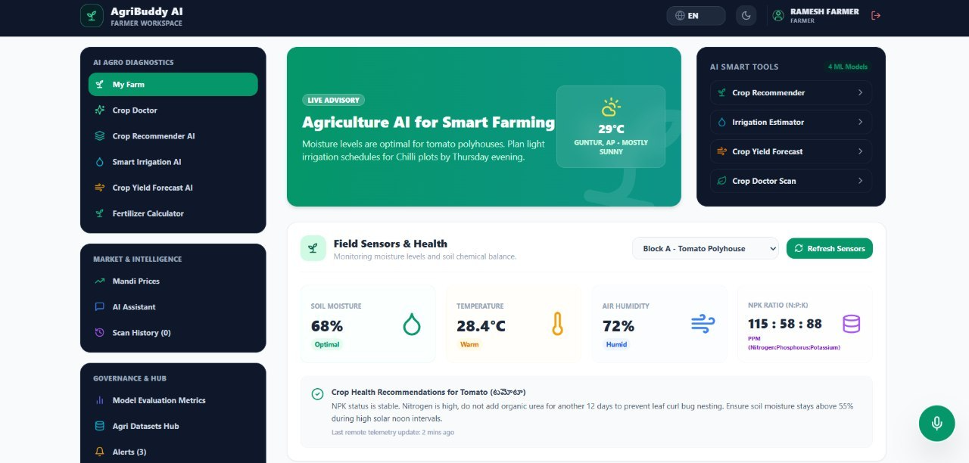

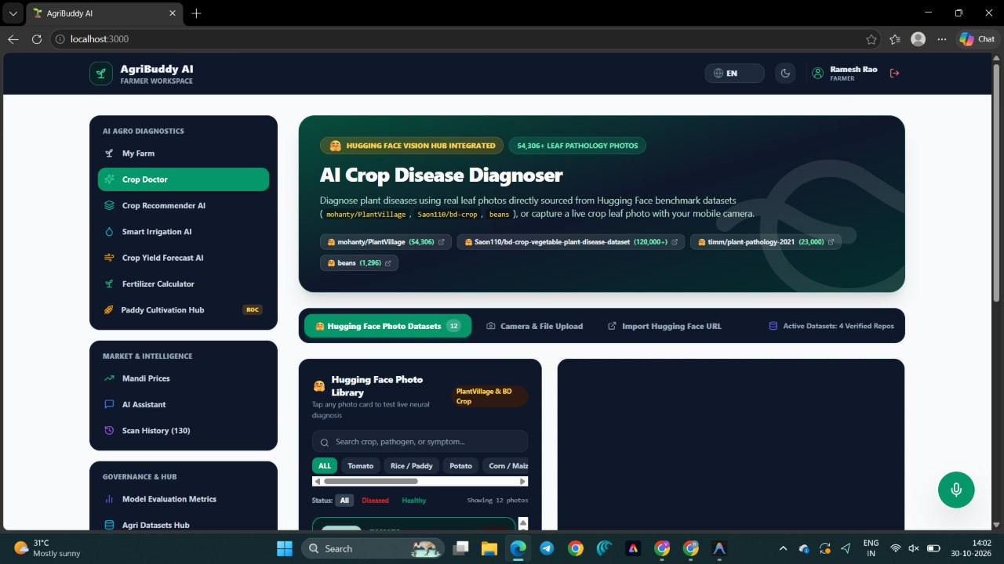

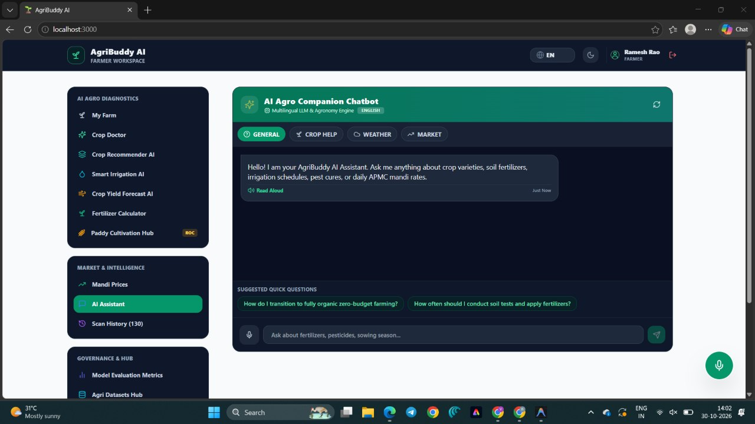

3.Model training and evaluation:

A. Project Workflow and Modules
1.Data Loading and Exploratory Analysis
The system loads agricultural datasets containing soil nutrient values, crop information, yield records, irrigation-related variables, and plant-leaf images. The data is inspected to understand its size, feature types, target classes, missing values, and class distribution.
Purpose: To verify data quality and identify the features required for each prediction task.
Source files: Dataset-loading and training filenames must be confirmed from the project repository.
2. Data Cleaning and Preprocessing
The preprocessing stage prepares structured agricultural data and plant images for model training. It includes checking missing values, selecting relevant features, scaling numerical data where required, and validating uploaded leaf images. The disease-detection module also checks for non-plant images and blurry images.
Purpose: To improve input quality and ensure that data is compatible with the selected models.
Source files: Refer to the actual preprocessing functions in the backend and machine-learning directories.
3. Feature Preparation and Model Training
The system trains and compares Random Forest, LightGBM, XGBoost, Decision Tree, and Support Vector Machine (SVM) models for relevant agricultural tasks. Random Forest and XGBoost are also evaluated for irrigation and yield prediction.
Purpose: To identify suitable algorithms for crop recommendation, plant disease detection, irrigation estimation, and yield forecasting.
Source files: Refer to the model-training scripts and saved model configuration files.
4. Evaluation, Plots, and Error Analysis
The models are evaluated using task-appropriate metrics. Classification models use accuracy, precision, recall, and F1-score. Regression models use mean absolute error (MAE), root mean squared error (RMSE), and R². Inference latency is also recorded.
Purpose: To compare models, identify prediction errors, and select a suitable model for each task.
Source files: The QA report identifies ml/evaluations.json as the file containing saved evaluation metrics. The exact plotting and error-analysis filenames must be confirmed from the repository.

B. Machine-Learning Implementation
1. Baseline and Comparison Models
AgriBuddy AI compares multiple algorithms instead of relying on a single prediction model.
Random Forest: Uses an ensemble of decision trees and is applied to crop recommendation, disease classification, irrigation prediction, and yield forecasting.
LightGBM: Uses gradient-boosted decision trees and is evaluated for crop recommendation.
XGBoost: Uses gradient boosting and is evaluated for crop recommendation, irrigation prediction, and yield forecasting.
Decision Tree: Provides a comparatively simple model for classification and performance comparison.
Support Vector Machine (SVM): Separates classes using decision boundaries and is evaluated for crop recommendation and plant disease classification.
Random Forest acts as a strong baseline for the crop recommendation task, while the other algorithms provide comparison points. For irrigation and yield prediction, Random Forest and XGBoost are compared.
2. Important Parameters
The following hyperparameters should be documented from the actual training code.
Model | Important hyperparameters | Purpose
Random Forest | n_estimators, max_depth, min_samples_split | Controls the number and complexity of trees
LightGBM | n_estimators, learning_rate, num_leaves | Controls boosting iterations and tree complexity
XGBoost | n_estimators, learning_rate, max_depth | Controls boosting and model complexity
Decision Tree | max_depth, criterion | Controls tree depth and splitting method
SVM | C, kernel, gamma | Controls the decision boundary and regularization
The available QA report does not specify the exact hyperparameter values, random seed, or validation strategy. These must be obtained from the training scripts rather than assumed.
3. Evaluation Results
The QA report records the following results:
Task | Model | Reported result
Crop recommendation | Random Forest | 99.55% accuracy
Crop recommendation | LightGBM | 99.09% accuracy
Crop recommendation | XGBoost | 99.09% accuracy
Crop recommendation | Decision Tree | 98.64% accuracy
Crop recommendation | SVM | 97.95% accuracy
Leaf disease detection | Random Forest | 97.81% accuracy
Irrigation prediction | XGBoost | MAE: 1.65 mm; R²: 0.982
Yield forecasting | XGBoost | MAE: 1.35 quintals/acre; R²: 0.948
These are the values documented in the QA report. They should be identified as independent test results only if the evaluation code confirms that they were obtained from a held-out test set.
4. Best-Model Selection
For crop recommendation, Random Forest achieved the highest reported accuracy among the five compared models. For irrigation and yield regression, XGBoost achieved the reported MAE, RMSE, and R² values shown above.
Final model selection should consider validation performance, precision and recall where applicable, inference speed, and generalization to unseen data. Preprocessing steps such as imputation and feature scaling must be fitted on training data only. The validation set is used for model selection, and the independent test set is reserved for final evaluation.

C. Demonstration and API
AgriBuddy AI provides a web-based interface built using React, TypeScript, and Vite, with a FastAPI backend and PostgreSQL database.
1. User input
Users can provide agricultural information, request crop recommendations, submit leaf images for disease detection, and access irrigation and yield predictions through the web interface.
2. Input validation
The backend validates incoming requests. The disease-detection endpoint checks uploaded images and rejects unsuitable non-plant images. The QA report records a successful HTTP 400 response for rejected non-plant images.
3. Model loading and prediction
The backend connects incoming requests to the relevant machine-learning prediction functions. The system returns task-specific outputs, such as recommended crops, disease classifications, irrigation requirements, or estimated yield.
4. Prediction display
The React frontend displays the returned predictions and related agricultural information. The system also supports fertilizer recommendations, weather advisories, and an agricultural assistant with English, Telugu, and Hindi responses.
5. API testing
The QA report documents the following endpoints:
POST /api/ml/crop-recommendation
POST /api/ml/disease-detection
POST /api/ml/irrigation-prediction
POST /api/ml/yield-prediction
POST /api/fertilizer-recommendation
GET /api/health
The QA report records 42 automated test scenarios passing after bug fixes, along with a successful frontend build. These results describe the reported QA run; they do not independently establish real-world agricultural accuracy.
6. Source code and repository
The QA report identifies main.py as a backend source file and ml/evaluations.json as the saved evaluation-metrics file. The exact model-training, preprocessing, plotting, and model-loading filenames should be added after checking the repository structure.

RESULTS AND DISCUSSION

AgriBuddy AI uses agricultural data to support crop recommendation, plant disease detection, irrigation prediction, yield forecasting, and fertilizer recommendation. The reported crop-recommendation evaluation uses 2,200 records across 22 crop classes, while the plant disease detection module supports 32 disease classes. The available QA report does not specify the complete dataset size for disease detection, the exact class-wise distribution, or the train-test split. These details should be obtained from the actual datasets and training code before final submission.

Model | Accuracy (%) | Precision (%) | Recall (%) | F1-Score (%) | Latency (ms)
SVM | 97.95 | 98.14 | 97.95 | 97.98 | 0.08
Decision Tree | 98.64 | 98.74 | 98.64 | 98.66 | 0.02
XGBoost | 99.09 | 99.15 | 99.09 | 99.09 | 0.07
LightGBM | 99.09 | 99.18 | 99.09 | 99.10 | 0.06
AgriBuddy Random Forest | 99.55 | 99.60 | 99.55 | 99.56 | 0.12

Graph:

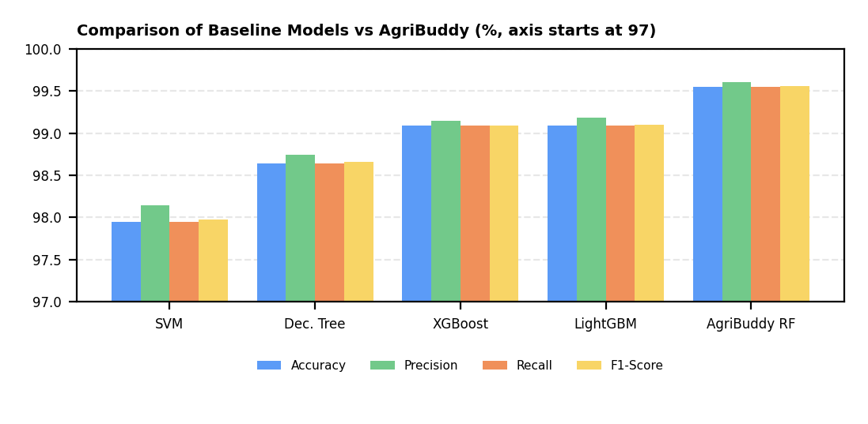

Random Forest achieved the highest individual-model accuracy of 99.55%, while SVM recorded the lowest at 97.95%. The RF–XGBoost Fusion (AgriFuse-XR) row reports 99.64% accuracy, but these fusion results require experimental verification.

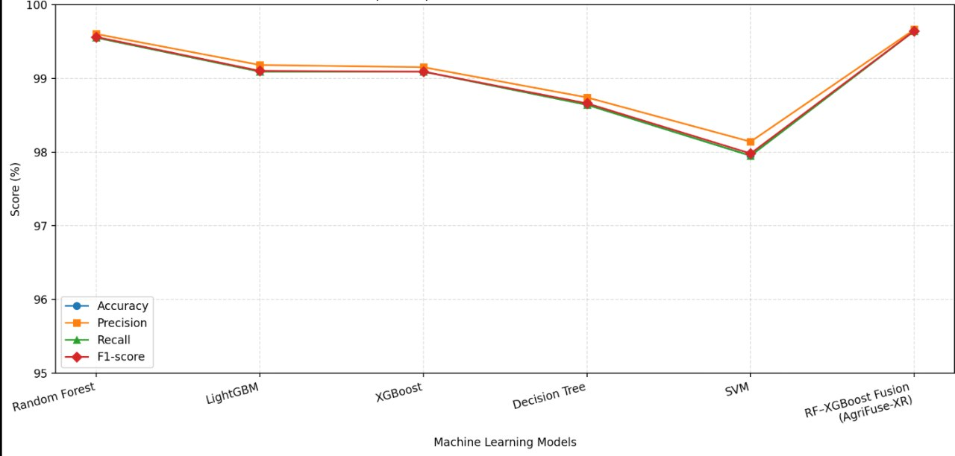

Accuracy:
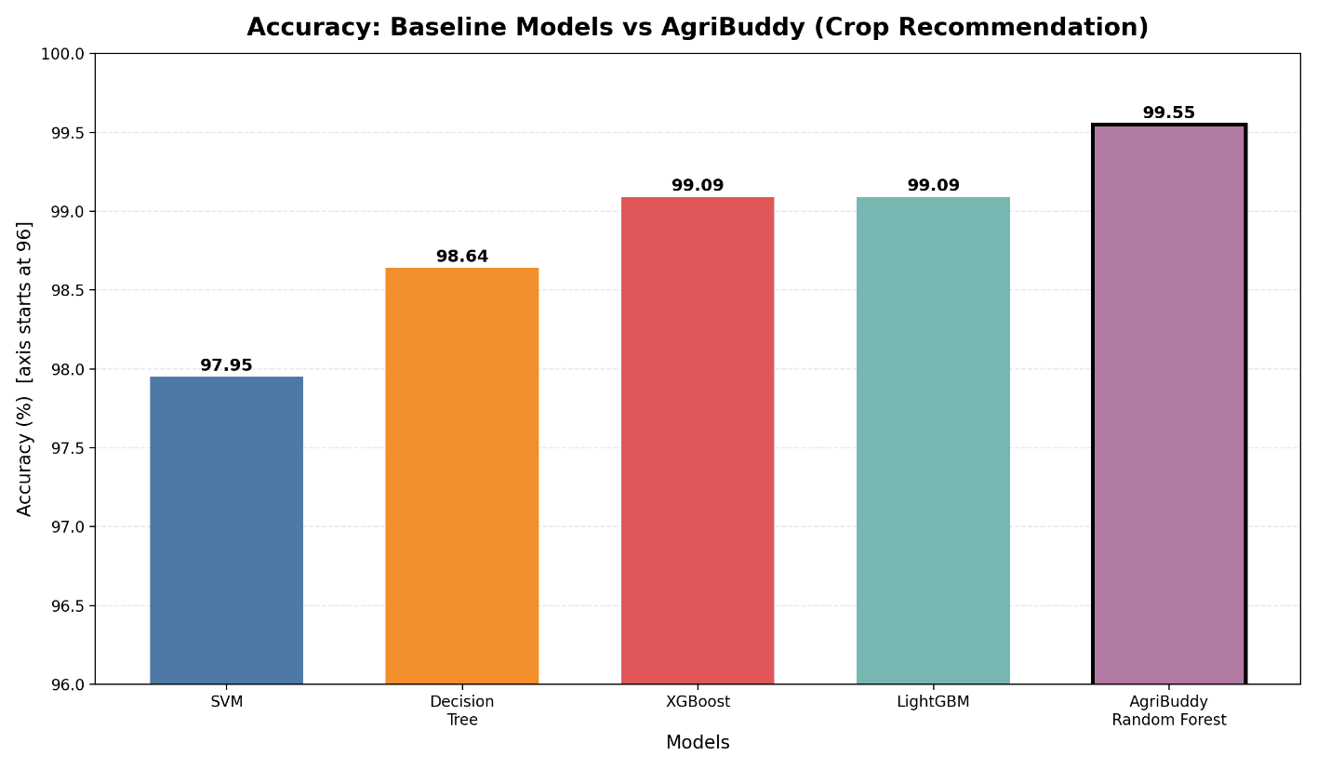

Precision:
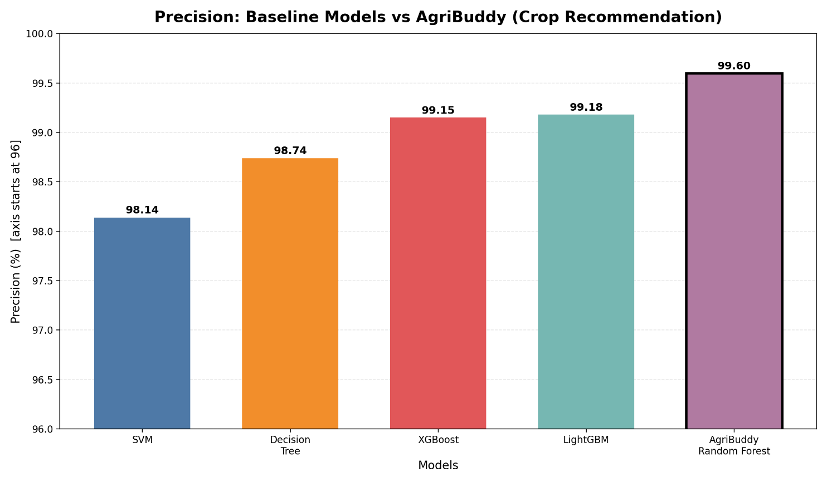

Recall:
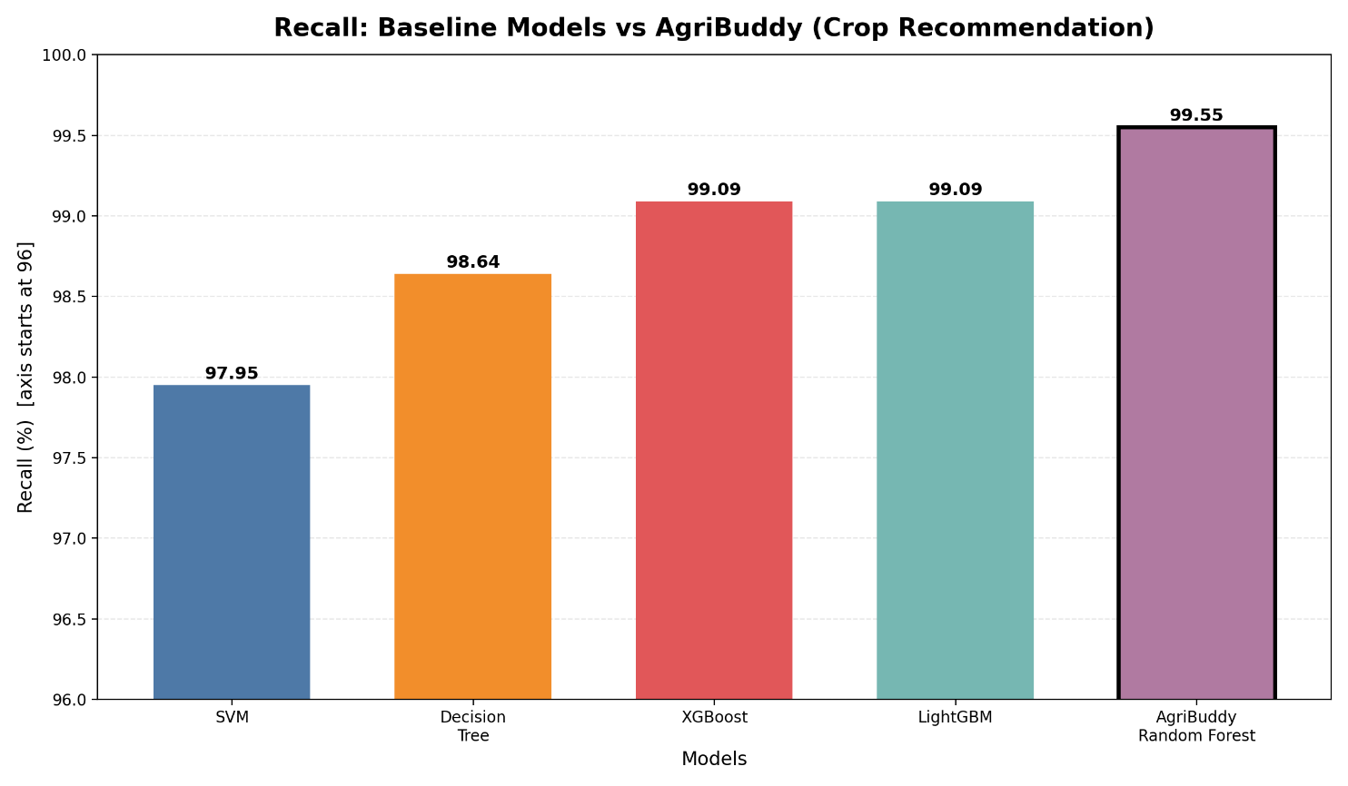

F1Score:
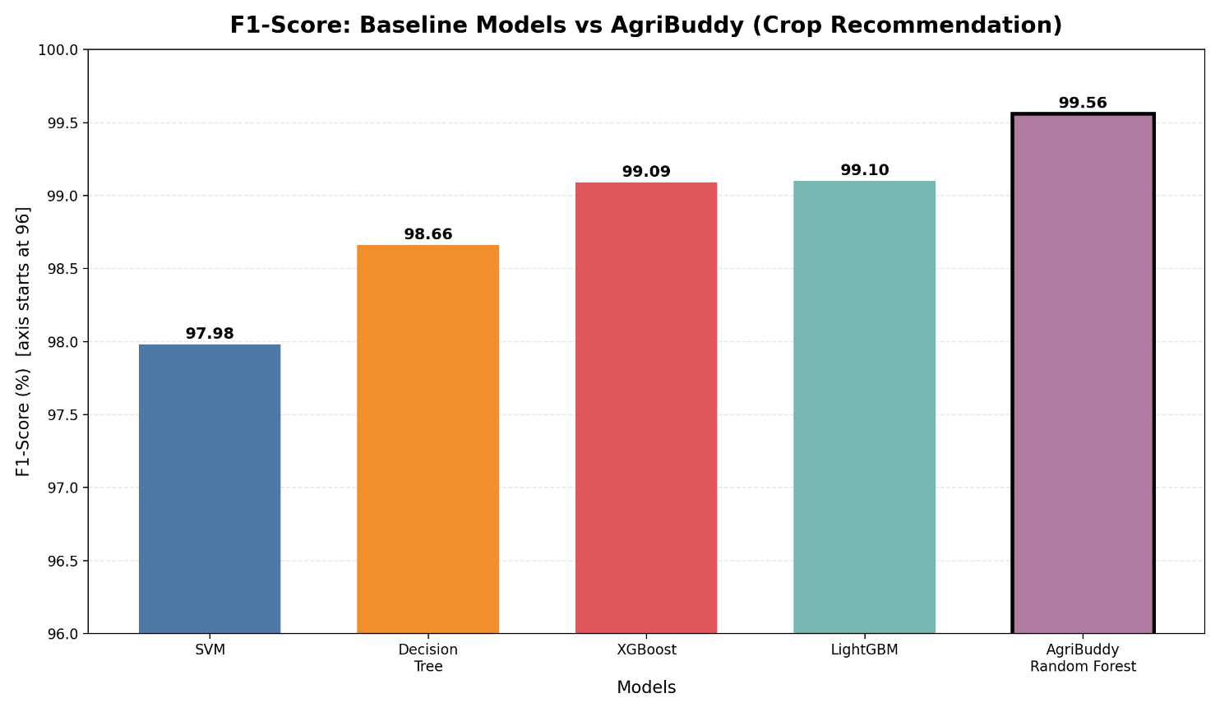

Inference Latency:
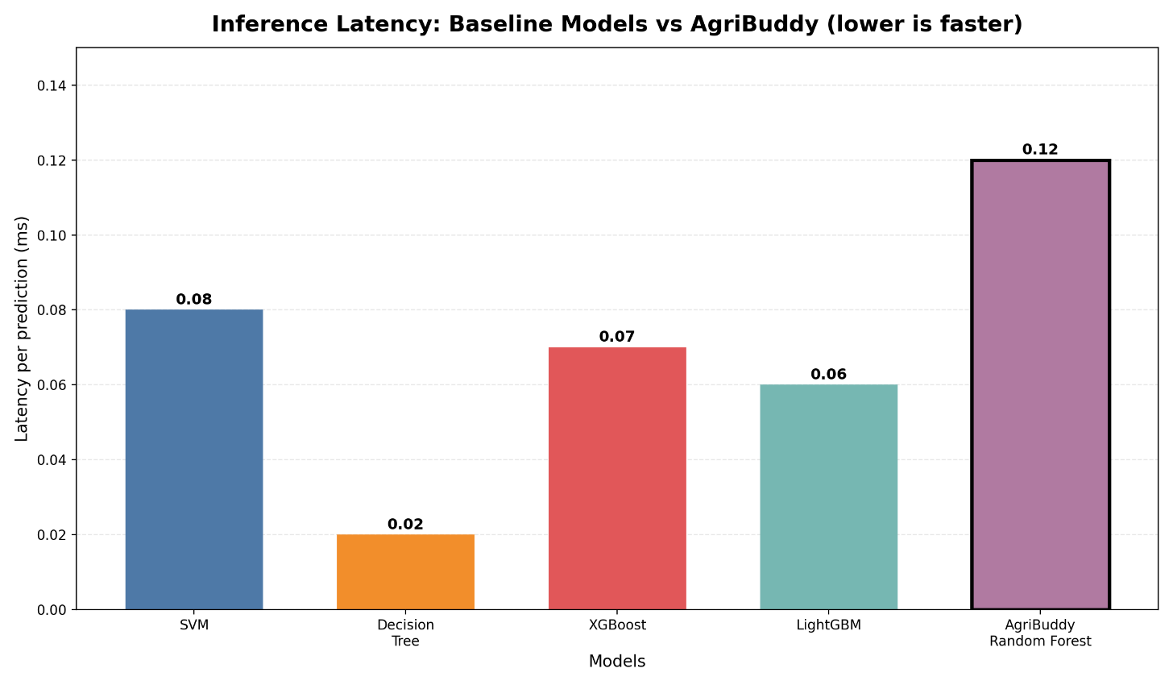

CONCLUSION AND FUTURE SCOPE

Conclusion:
AgriBuddy AI is an AI-powered smart agriculture system developed to support farmers in making better farming decisions. The project addresses the challenges of crop selection, plant disease detection, irrigation planning, and crop yield prediction using machine learning models integrated with a service-oriented architecture (SOA).
The system evaluates Random Forest, Decision Tree, SVM, XGBoost, and LightGBM for crop recommendation and compares their performance using accuracy, precision, recall, and F1-score. Among the tested crop recommendation models, Random Forest achieved the highest measured accuracy of 99.55%. For irrigation prediction, XGBoost achieved an R² score of 0.982, while for yield prediction, it achieved an R² score of 0.948. The plant disease detection model achieved an accuracy of 97.81% using Random Forest.
The main objectives of developing an AI-based agriculture support system and evaluating machine learning models were addressed through the implemented modules and reported evaluation results. However, the system has limitations: physical sensors are not connected, some inputs are simulated, and the models require further validation on diverse real-world agricultural data. The RF–XGBoost fusion model, AgriFuse-XR, requires separate experimental evaluation before its performance can be confirmed.

Future Scope:
Future improvements to AgriBuddy AI may include:
Larger datasets: Test the models using more diverse agricultural data from different regions, seasons, and soil conditions.
Disease detection improvements: Address class imbalance and evaluate disease detection across different plant varieties and environmental conditions.
Fusion model evaluation: Experimentally evaluate AgriFuse-XR and compare its results with individual models.
Real-time integration: Connect actual agricultural sensors and live weather data instead of relying on simulated inputs.
Explainable AI: Add explanations for crop recommendations, disease predictions, and irrigation decisions.
Multilingual chatbot: Improve farmer assistance in Telugu, Hindi, and English.
Deployment and monitoring: Deploy the system for practical use and monitor prediction accuracy, response latency, and changes in incoming agricultural data.

REFERENCES
1.Prity, F. S., Hasan, M. M., Saif, S. H., et al. (2024). Enhancing Agricultural Productivity: A Machine Learning Approach to Crop Recommendations. Human-Centric Intelligent Systems, 4, 497–510. https://doi.org/10.1007/s44230-024-00081-3
2.Mohanty, S. P., Hughes, D. P., & Salathé, M. (2016). Using deep learning for image-based plant disease detection. Frontiers in Plant Science, 7, 1419. https://doi.org/10.3389/fpls.2016.01419
Note: This is a foundational paper, not a 2024–2026 publication.
3.Kole, P., Patil, S., & Patil, J. (2025). An IoT–Machine Learning–Decision Support System Framework for Smart Agriculture: Design, Implementation, and Performance Evaluation. International Journal of Applied Mathematics, 38(10s). https://doi.org/10.12732/ijam.v38i10s.1431
4.An Approach for Crop Recommendation with Uncertainty Quantification Based on Machine Learning for Sustainable Agricultural Decision-Making. (2025). Results in Engineering, 26, 105505. https://doi.org/10.1016/j.rineng.2025.105505
5.Sawant, N. R., Kumar, A., Pant, S., et al. (2026). An IoT-driven machine learning system for real-time smart crop recommendation and optimization in precision agriculture. Discover Artificial Intelligence. https://doi.org/10.1007/s44163-026-00896-y
6.Umamaheswari, M., & Kavitha, D. (2026). Machine learning classification techniques for smart agriculture: A review of disease detection and crop recommendation. Frontiers in Artificial Intelligence, 9, 1878006. https://doi.org/10.3389/frai.2026.1878006
7.Scikit-learn Developers. (n.d.). Scikit-learn documentation. https://scikit-learn.org/stable/
8.XGBoost Developers. (n.d.). XGBoost documentation. https://xgboost.readthedocs.io/
9.LightGBM Contributors. (n.d.). LightGBM documentation. https://lightgbm.readthedocs.io/
10.FastAPI. (n.d.). FastAPI documentation. https://fastapi.tiangolo.com/

